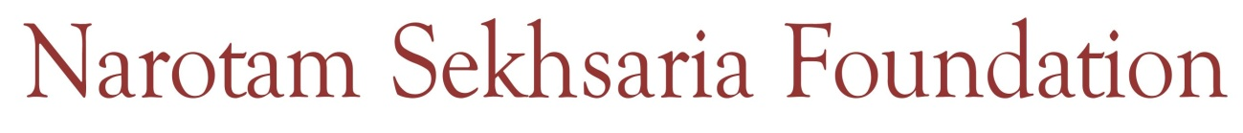
NGO Grant Application form

Name of the organization:

Name of the head of the organization:

Personal Details
Name:
Address:
Telephone:
Mobile:
Email:

Registration details
State:
Number:
Date:

Please enclose the following
Past activities in tobacco control:
(Narrative report, audio and video documentation, awards or recognition received)

Audited accounts for last three years:

Memorandum of Association and Trust Deed:

Sources of funds received during last three years:

80 G certificate

12 A certificate

Copy of the Pan card

N.B. Based on the preliminary screening process the Foundation can ask for additional documents.
Applications should be sent by Post or Email.

Email – nsfawards@nsfoundation.co.in

Address – Narotam Sekhsaria Foundation
1st Floor, Nirmal Building:
Nariman Point
Mumbai No: 400021
61326200

